This is my Home Page

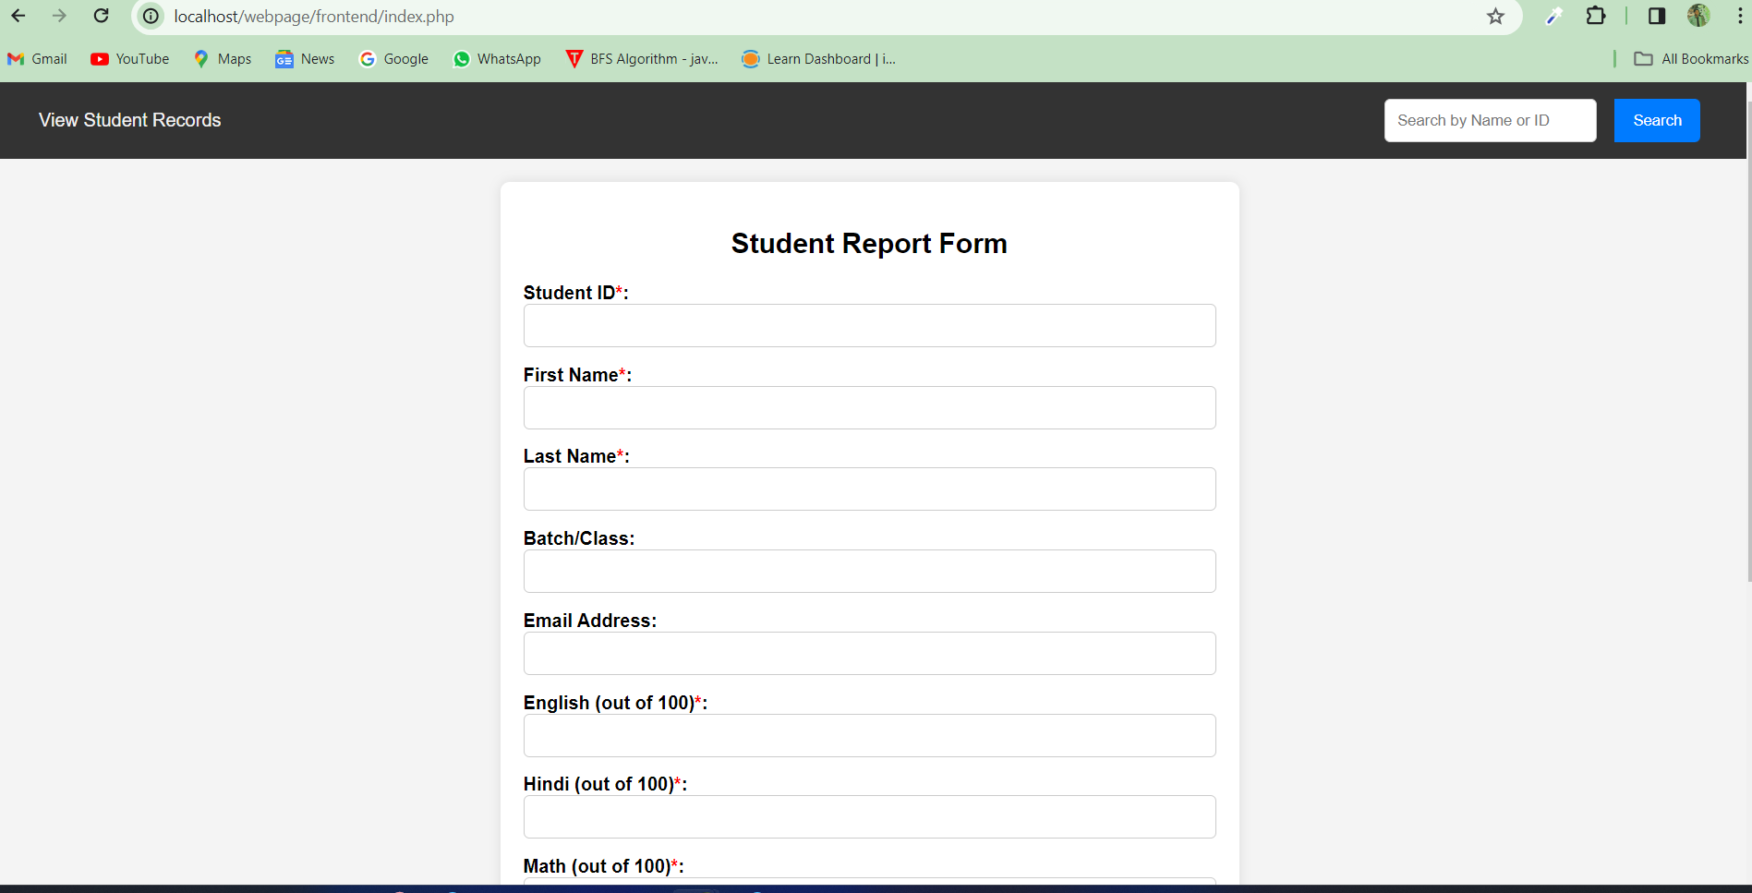

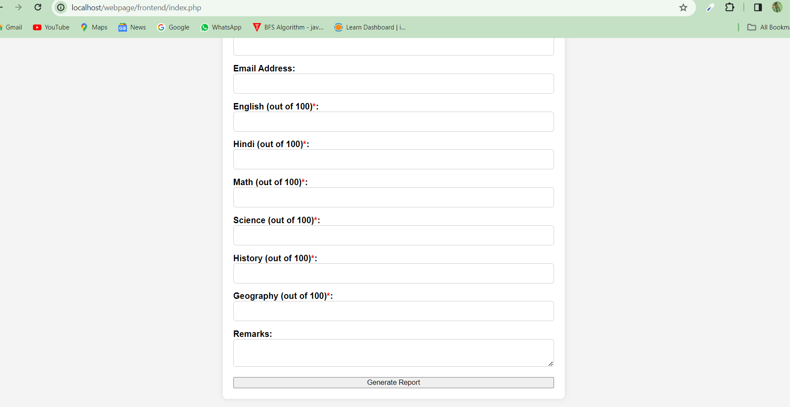

"If you click on 'View Student Records', it will show you the previous students' data which is coming from the database.

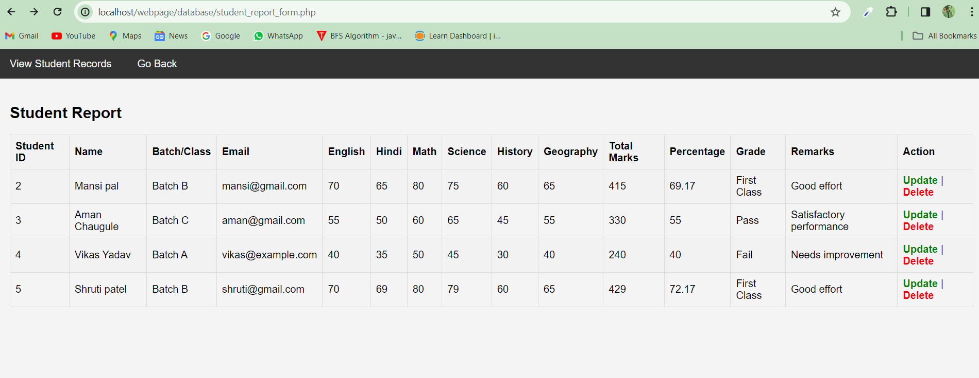

Here, you can see the list of student details.

You can update and delete the student details as well.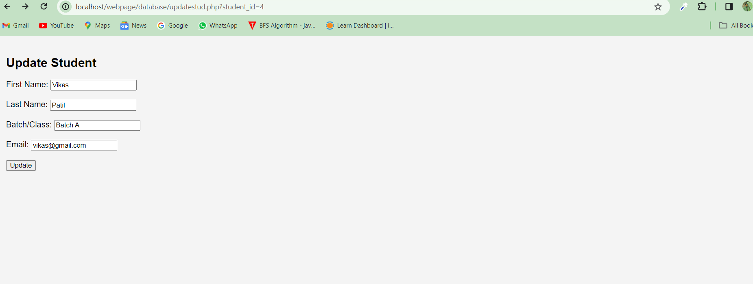

Here I have changed the last name of Vikas from Yadav to Patil

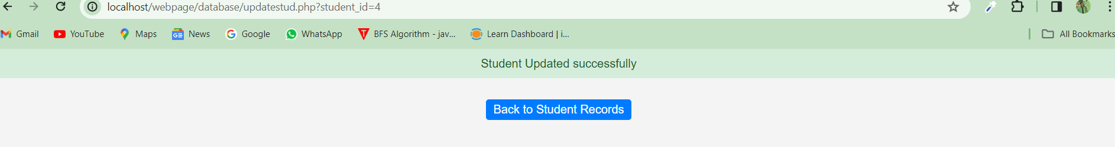

See the Records

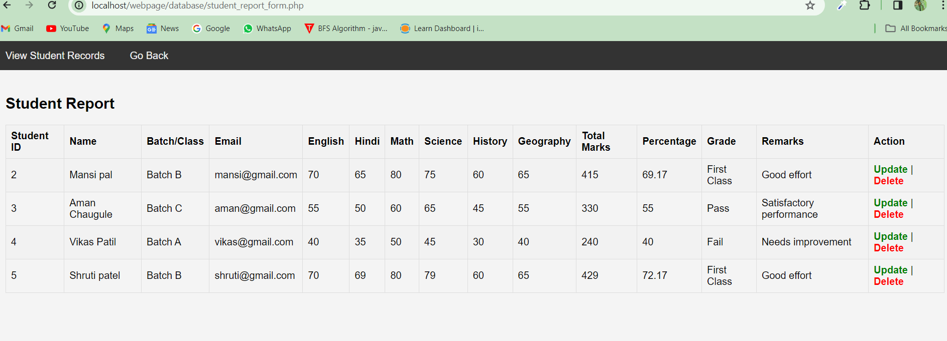

Similarly, I can delete the student records  
  
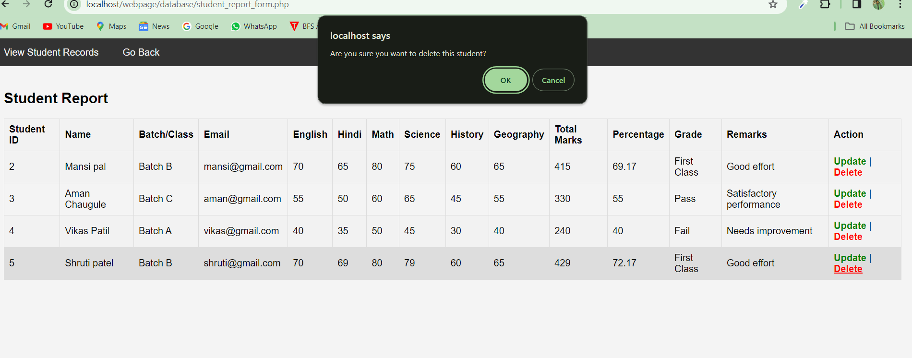

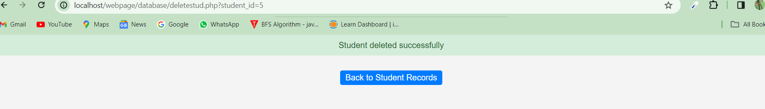

I can Insert the data, and that data will be stored in the database

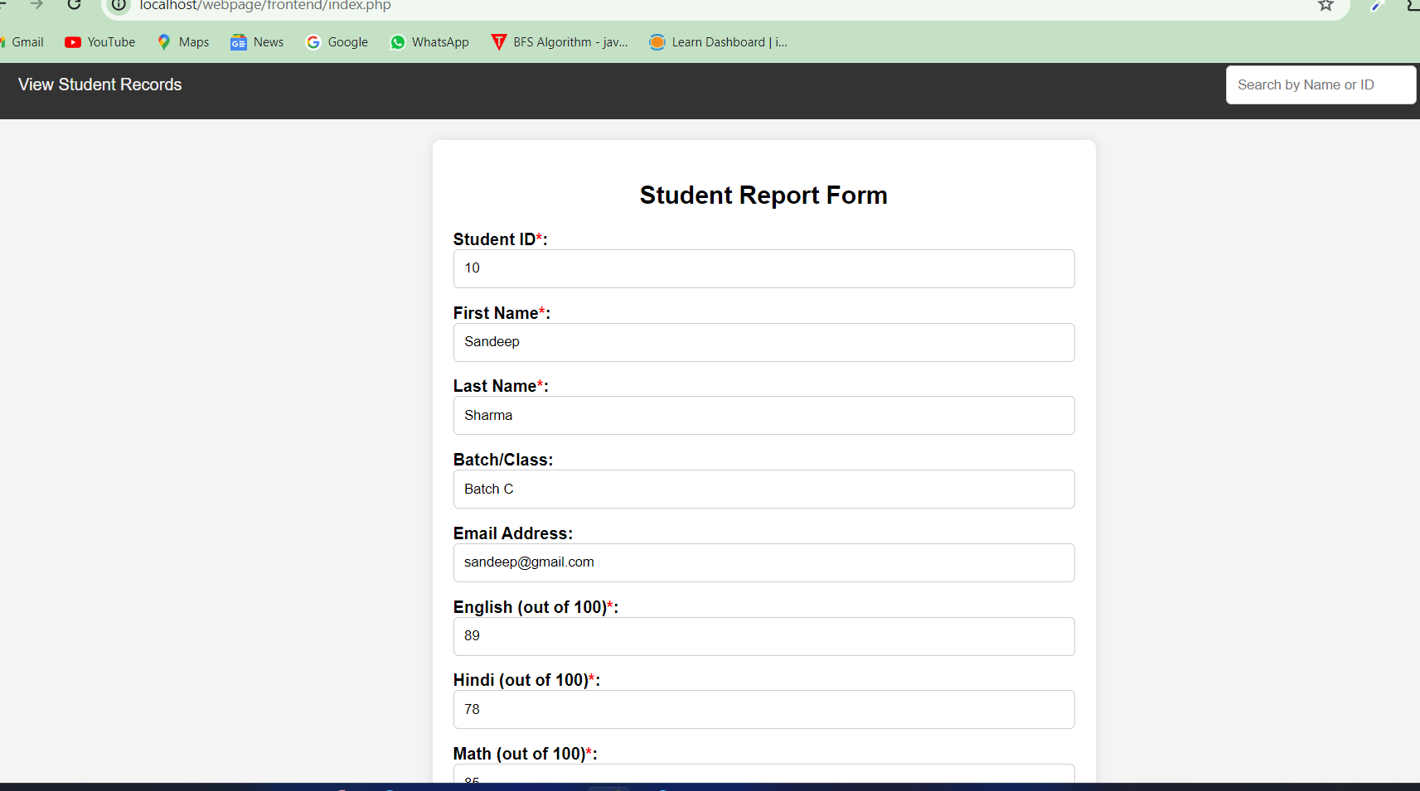

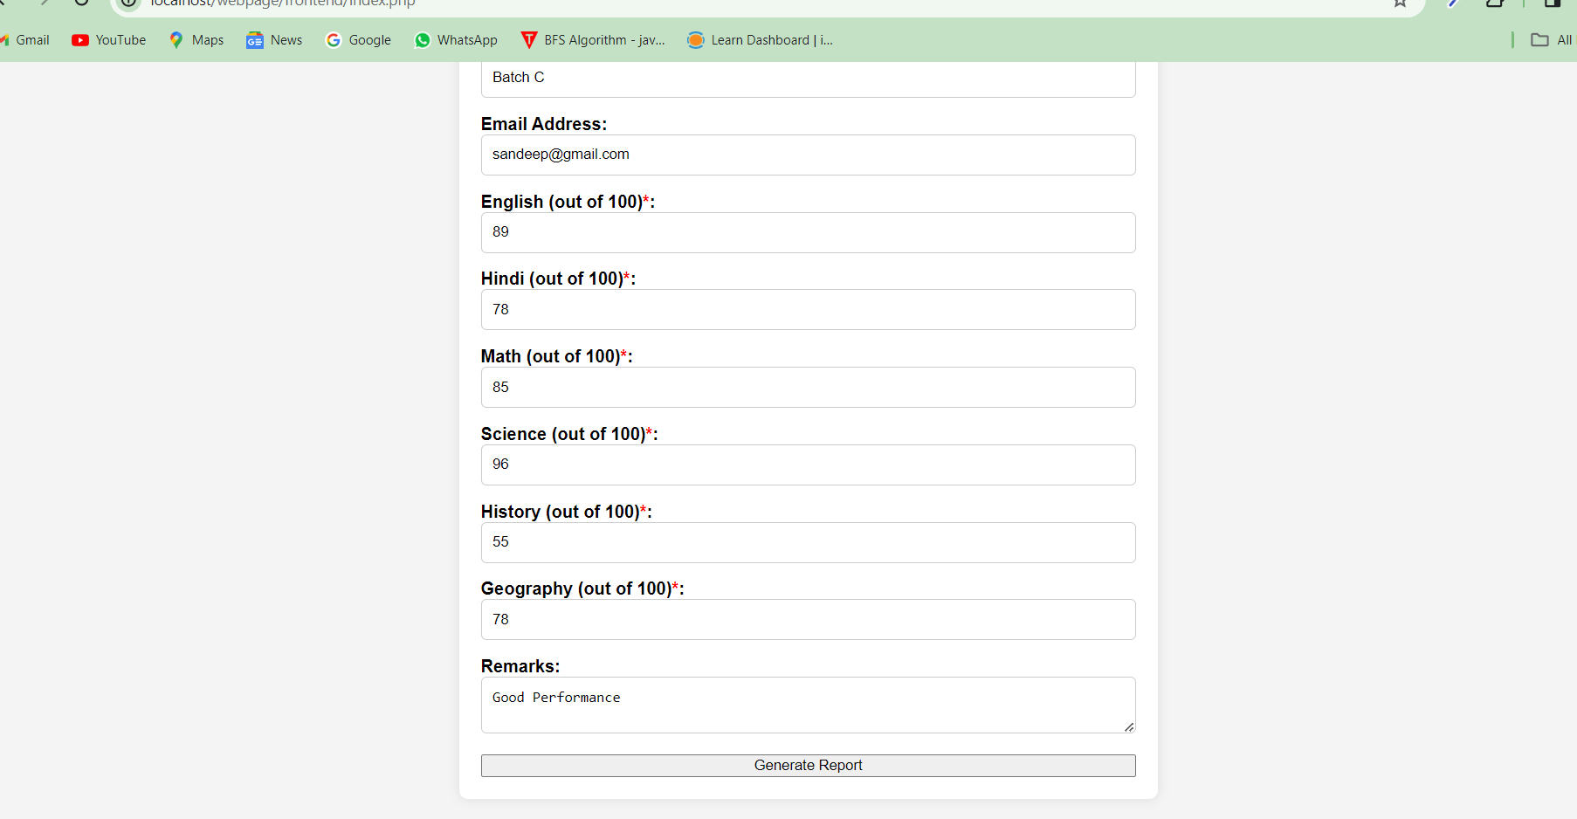

After clicking on Generate Report , It will Calculate the total marks, percentage and grade and store them into the database

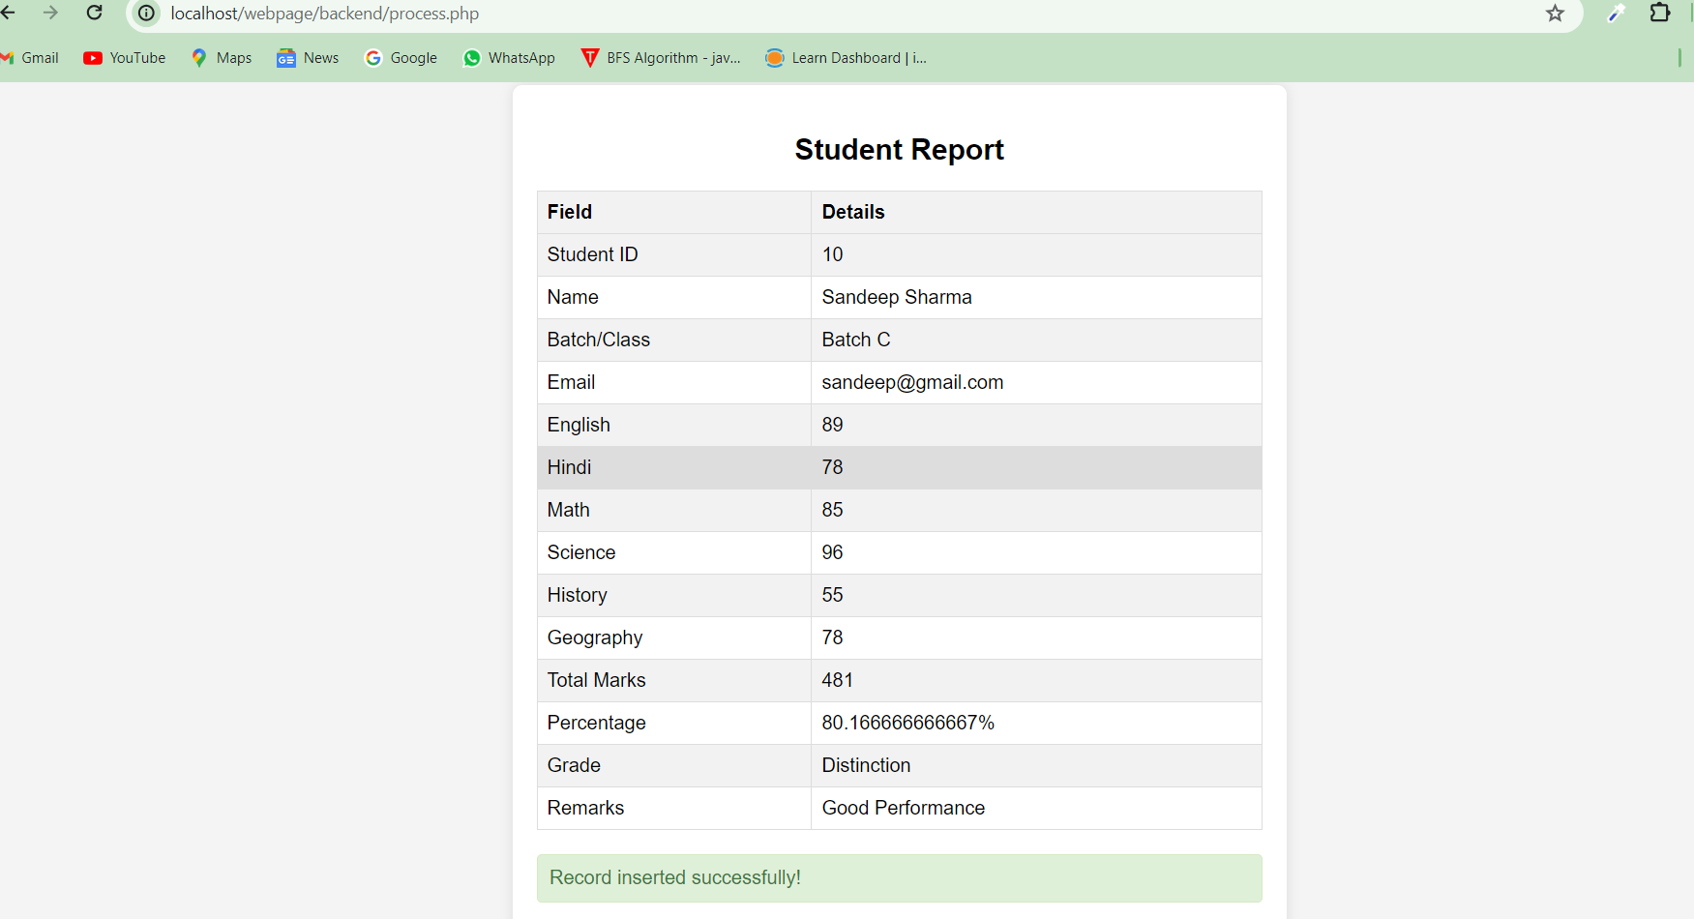

I have integrated a search bar in navigation bar , based on Id or name, we can fetch the data

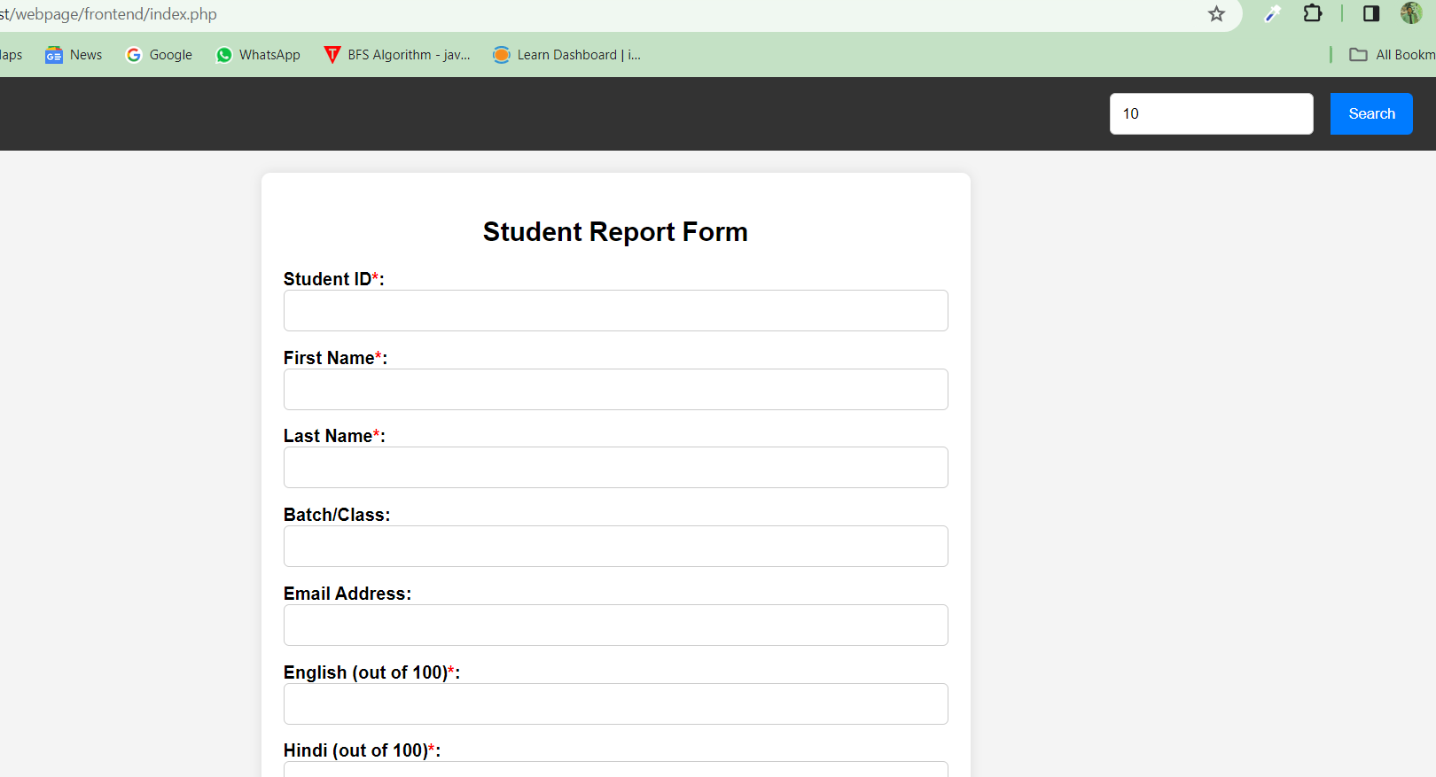

I have written 10 in the search bar, After clicking on submit button, we can see the entire details of that students

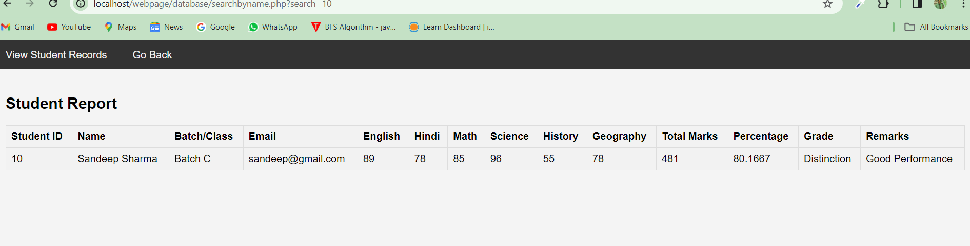

This is my phpMyAdmin panel

